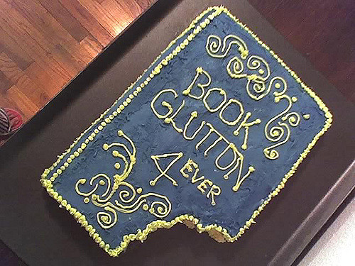Bite

Into

Books

Dear Parents of Highlands Elementary School Second Grade Students,

The second grade classrooms will participate with the Community Library of Allegheny Valley in the “Bite Into Books” program. Mrs. Susan Wilson, the youth services librarian, will visit each second grade class for a 45 minute lunch/recess period. This will occur twice in each classroom throughout the year. Students listen to a story while enjoying their lunch. Following the story, students create a hands-on craft and sample a snack related to the story.

Our goal is to create a love and enjoyment of books through a school-community connection in an engaging environment that fosters a lifelong love of reading.

We are so excited to have Mrs. Wilson offer this beneficial program to Highlands Elementary School! The schedule is on the back and it will also be posted on the Highlands website. Be sure to ask your child about their “Bite Into Books” lunch experience.

Ms. Chris Izydore, Highlands Elementary School Second Grade MTSS Facilitator

Mrs. Susan Wilson, Allegheny Valley Community Library Youth Services Librarian

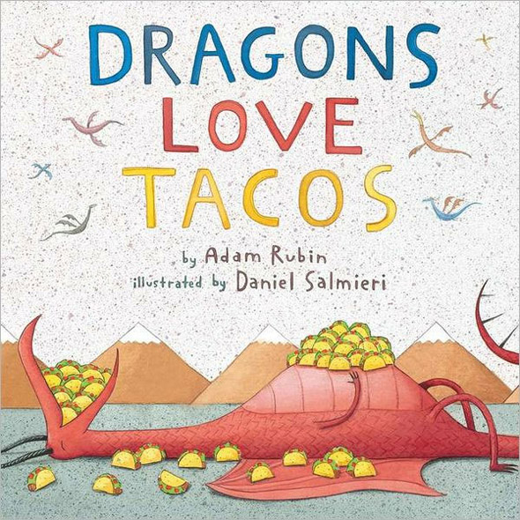

Schedule for “Bite Into Books”

Tuesday, November 5 & Wednesday, November 6 Mrs. Pittman (Room 101)

Tuesday, November 19 & Wednesday, November 20 Mr. Celko (Room 19)

Tuesday, December 3 & Wednesday, December 4 Mr. Stinelli (Room 18)

Tuesday, January 14 & Wednesday, January 15 Mrs. Krenzer (Room 108)

Tuesday, February 11 & Wednesday, February 12 Miss McCurdy (Room 111)

Tuesday, March 11 & Wednesday, March 12 Mrs. Snyder (Room 110)